**Task # 1:** Design a webpage including html & CSS. Include all the things told in lab and the things included in assignment. The following navigation tabs must be added:

1. Home ( Give info about what your website is about)
2. Information (Include the detailed information related to the particular technology)
3. Gallery (Include images and Videos of technology)
4. About (Give the information about yourself)

**Home (Give info about what your website is about)**

Solution:

<!DOCTYPE html>

<html lang="en">

<head>

    <link rel="stylesheet" href="task 8 .css">

</head>

<ul>

    <li><a class="active" href="home.html">Home</a></li>

    <li><a href="information.html">Information</a></li>

    <li><a href="gallery.html">Gallery</a></li>

    <li><a href="about.html">About</a></li>

</ul>

 <body style="background-color:hsl(173, 11%, 85%);">">

    <center><h1>WELCOME</h1>

        <h2>YOUTH ADVENTURE CLUB</h2>

        <h3>Explore Colorful World With Us</h3>

        <h4>We provide you an opportunity to adventure,

            explore and travel in an youthful way</h4>

            <img src = "Capture.PNG" height="260"width="310">

        </center>

    </body>

</html>

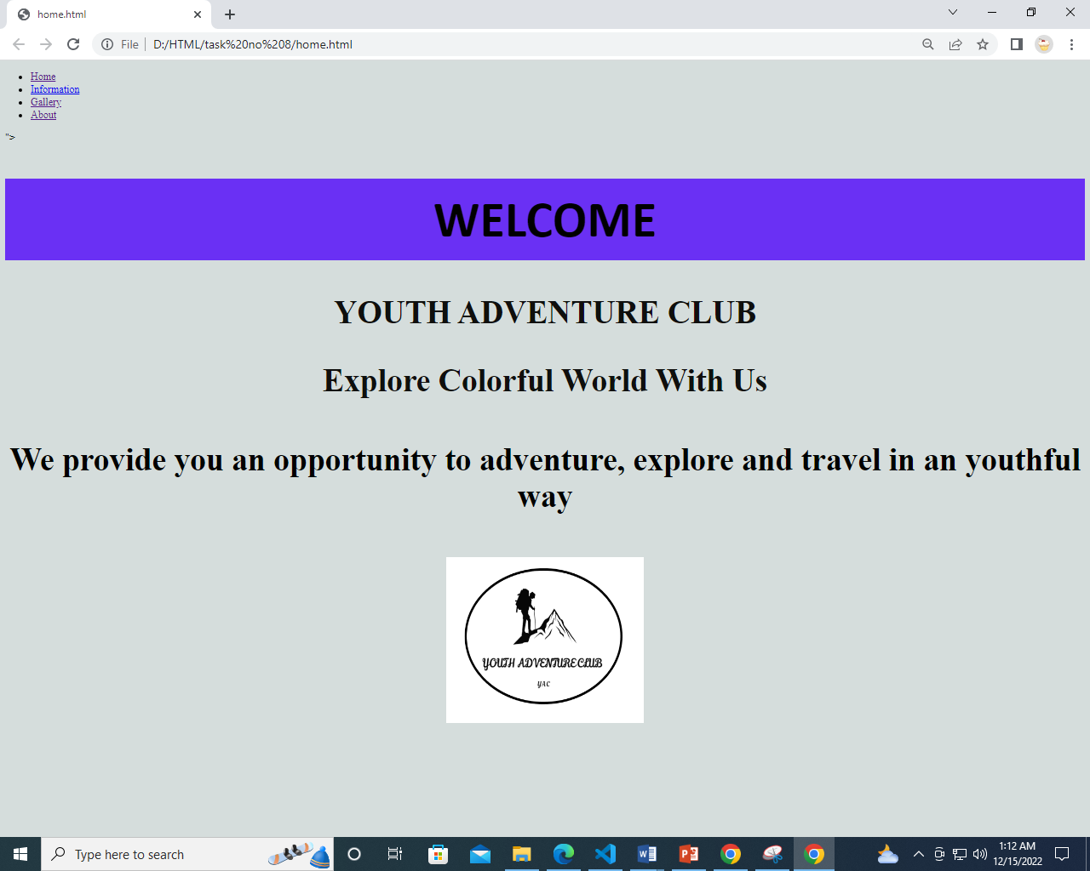

**Information (Include the detailed information related to the particular technology)**

Solution:

<!DOCTYPE html>

<html>

<head>

<link rel="stylesheet" href="task 8 .css">

</head>

<ul>

    <li><a class="active" href="home.html">Home</a></li>

    <li><a href="information .html">Information</a></li>

    <li><a href="gallery.html">Gallery</a></li>

    <li><a href="about.html">About</a></li>

</ul>

<body style="background-color:hsl(173, 11%, 85%);">">

<center><h1>Our Information!</h1>

<h2>Services</h2>

<P>Tour consultancy,

    Student packages,

    Domestic and international trips,

    Camping,

    Hiking,

    Hunting,

    </P>

    <h3>International

    </h3>

    <P>Camping and hiking at Mount Everest (Nepal),

        Turkey trip,

        Switzerland trip,

        Europe trip (Italy, Spain and Greece),

        </P>

        <h4>Contact us

        </h4>

        <p>Location:

            Karachi,

            Lahore,

            Islamabad,</p>

       <p>     Phone:

021-00000000 /

0300 000000 </p>

<p>Website:

www.ayc.pk</p>

<p>Other platforms:

     info@ayc.com.pk/

     adventureyouthclub/

     adventureyouthclub/

     adventureyouthclub

            </p>

</center>

</body>

</html>

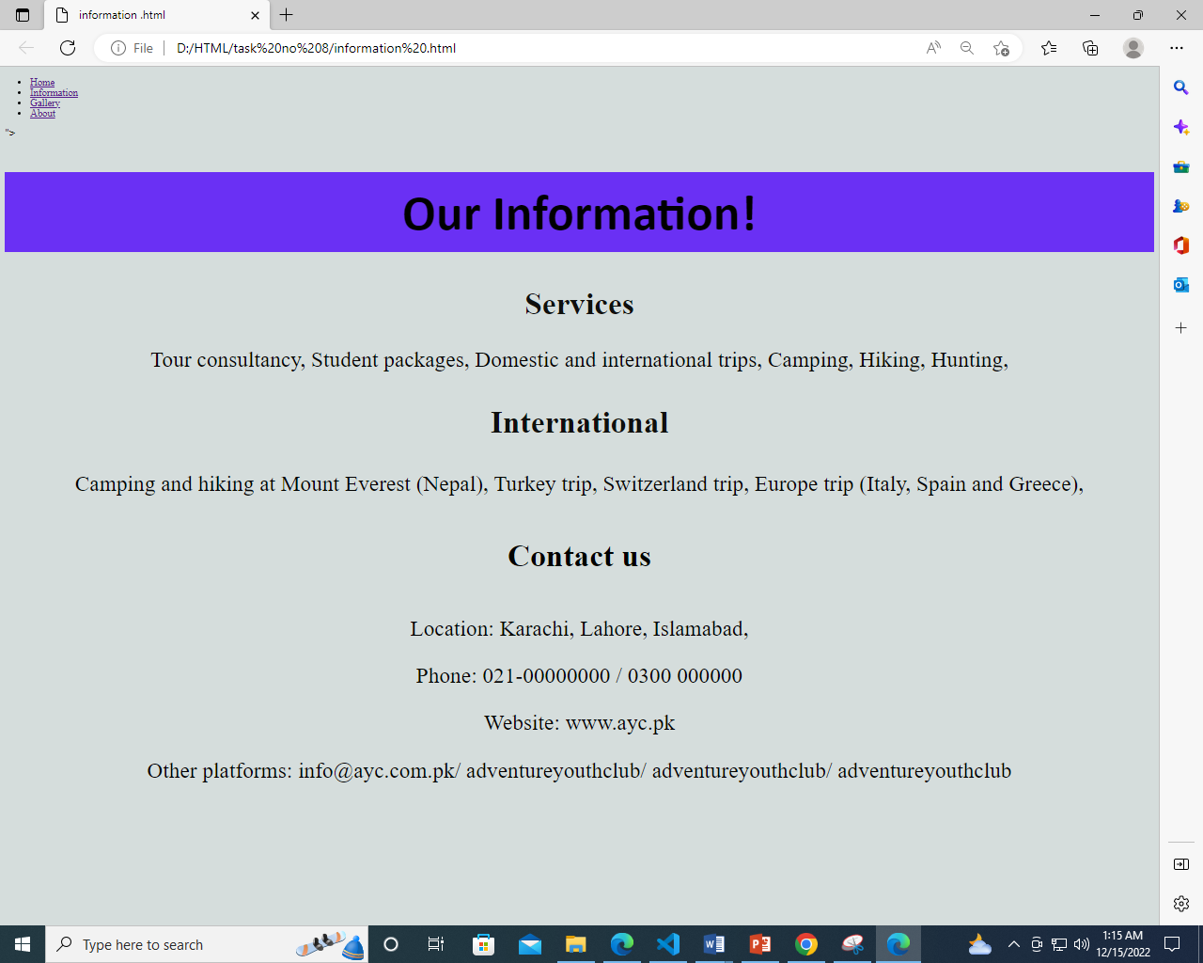

**Gallery (Include images and Videos of technology)**

Solution:

<!DOCTYPE html>

<html>

<head>

<link rel="stylesheet" href="task 8 .css">

</head>

<ul>

    <li><a class="active" href="home.html">Home</a></li>

    <li><a href="information.html">Information</a></li>

    <li><a href="gallery.html">Gallery</a></li>

    <li><a href="about.html">About</a></li>

</ul>

<body style="background-color:hsl(173, 11%, 85%);" padding="10">

<center><h1>Gallery</h1>

    <img src = "image _1.jpg.jpg" height="260"width="310">

    <img src = "download (1).jpg" height="260"width="310">

    <img src = "download (3).jpg" height="260"width="310">

    <img src = "Sharda_Bridge,neelam_vellay18apr17.jpg" height="260"width="310">

    <img src = "images (1).jpg" height="260"width="310">

    <img src = "download.jpg" height="260"width="310">

    <img src = "download (4).jpg" height="260"width="310">

    <img src = "neelum1.jpg" height="260"width="310">

</center></body>

</html>

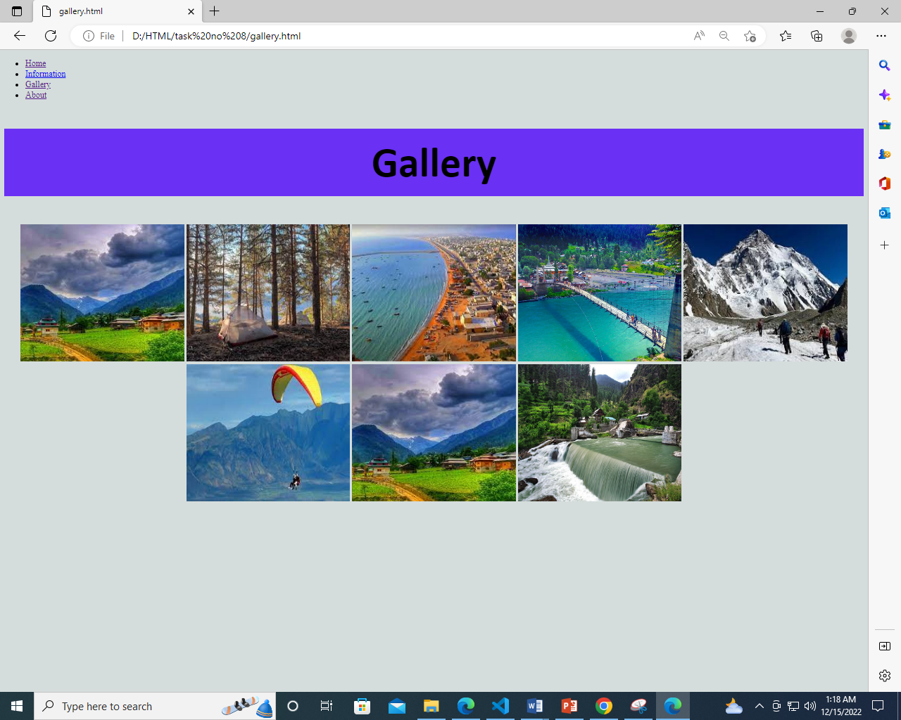

**About (Give the information about yourself)**

Solution:

<!DOCTYPE html>

<html>

<head>

<link rel="stylesheet" href="task 8 .css">

</head>

<ul>

    <li><a class="active" href="home.html">Home</a></li>

    <li><a href="information.html">Information</a></li>

    <li><a href="gallery.html">Gallery</a></li>

    <li><a href="about.html">About</a></li>

</ul>

<body style="background-color:hsl(173, 11%, 85%);" padding="10">

<center><h1>About us</h1>

  <p>Youth adventure club is one of the leading club in tourism industry. It have been working in this industry since 2000 and providing consultancy and adventurous trips to the youth with a different vision and help them to explore new things in their own way.

    Our motive is to provide an opportunity to youth to travel world by providing an excellent costumer service  in reasonable budget.

  </p>

</center></body>

</html>

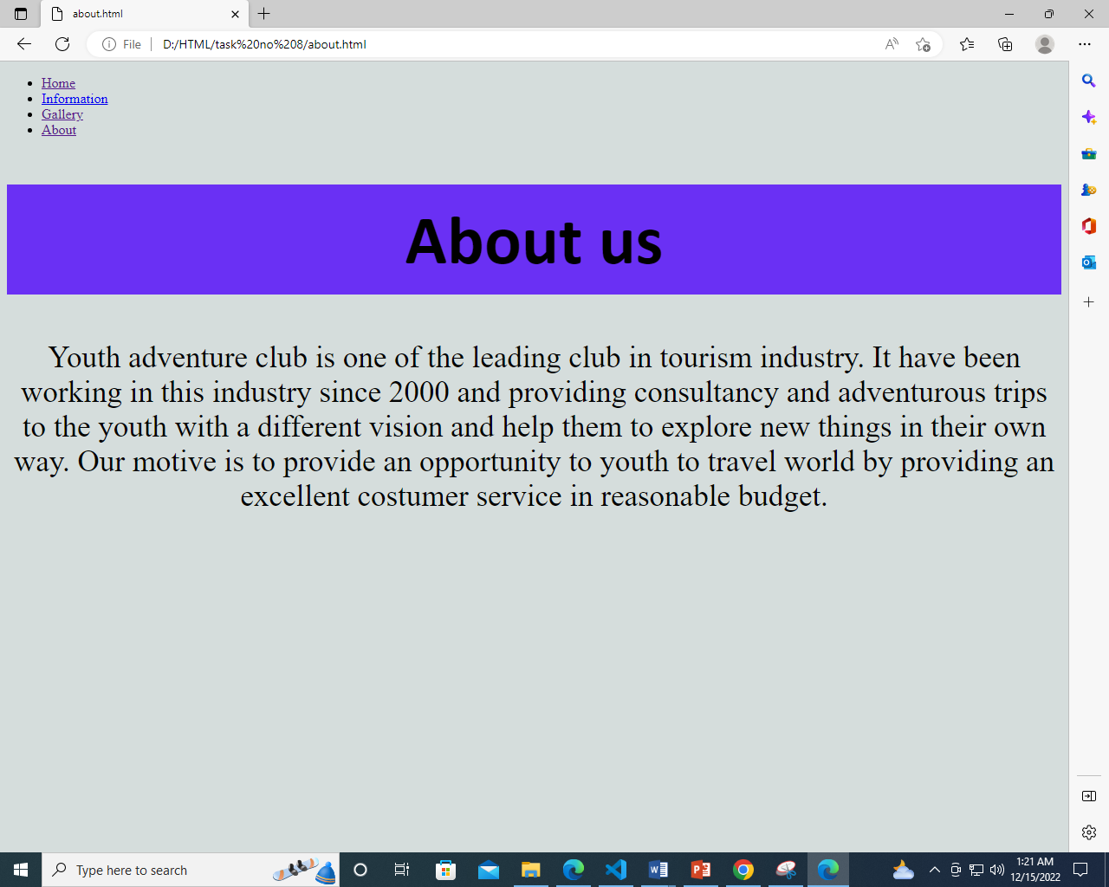

**Css Code:**

h1{

    background-color: rgba(81, 8, 250, 0.808);

    font-size: 80px;

    padding: 15px;

    font-style:bold;

    font-family: Calibri;

}

h2{

    color: rgb(15, 15, 13);

    font-size: 50px;

}

h3{

    color: rgb(27, 156, 38);

    font-size: 20px;

}

p{

    color: rgb(3, 3, 3);

    font-size: 20px;

}

h3{

    color: rgb(15, 15, 13);

    font-size: 50px;

}

h4{

    color: rgb(1, 2, 1);

    font-size: 50px;

}

p{

    color: rgb(3, 3, 3);

    font-size: 35px;

}